Environment Plan Example

1. What two things should you do to ensure environments are only created by authorized users?

**Assign admins the Power Platform Service Admin or Dynamics 365 service admin role**

**Restrict creation of new production environments to admins**

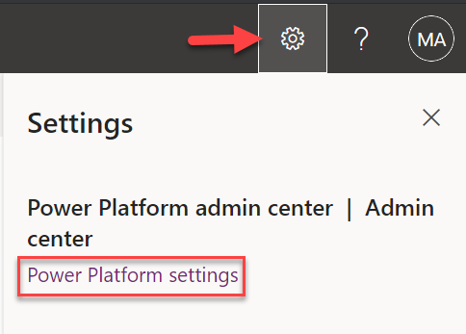

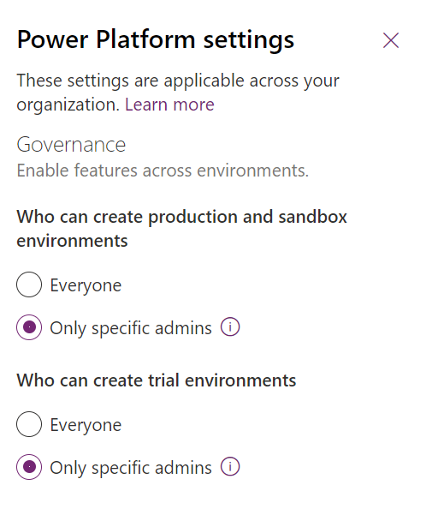

**This option is only available if you’re a global or service admin so you won’t see it in your lab user because you are only an environment admin**

1. What can you do to the default environment to make it clearer what its purpose is?

**Rename the default environment to Personal Productivity**

1. What type of environment should users use for trying things out or training?

**Use Trial or community plan environments**

1. What environments (and what type of environments) are needed to allow the market research department to have a better application lifecycle management process?

**The current environment should be considered their production environment and two new environments should be added to support development and testing. Instead of making changes directly in production the app makers should start making the changes in development. When the changes are ready, they should be promoted to testing and only to production once they've been successfully tested.**

1. How would you handle requests 1-5?

* Request 1: A user would like to build a set of Power Automate flows that helps organize their Outlook inbox and tags emails.

**They should build these in the default personal productivity environment.**

* Request 2: VP of Service wants to build some custom apps to support their teams; like how the market research team has done.

**After working with the team to determine that they are not just building personal productivity apps a dedicated development environment should be established. Using this development environment, they can start building their apps and once they are ready to publish them you should establish dedicated testing in production environments. However, prior to setting up the dedicated test and production environments you should meet with the team again and make sure their applications do not make sense to mix with other cast and production applications. For example, if they were sharing data with other departments it would not make sense to have them isolated in production because this would result in multiple copies of the data in the organization.**

* Request 3: Marketing wants to build an app that makes it easy to publish tweets on Twitter using their connector. They also plan to create Power Automate flows that notify them of mentions along with the sentiment of the message.

**After reviewing you have determined these request sounds a lot like personal productivity with the exception that they want to use a connector that is not allowed by the personal productivity environment DLP policies. You narrowed it down to two options to fulfill the request, first you Could direct them to the power users environment where you have allowed more trusted app makers to have a little more flexibility than the personal productivity environment. The second option is you could create a dedicated marketing sandbox that they could do their automation in. As you listened to the different types of connectors that they need you decided giving them a dedicated environment would be a better option.**

* Request 4: HR would like to try the Crisis Comms app that Microsoft published and would like an environment for it to run in.

**You helped them set up a trial environment so they could install and try out the app. If the evaluation proves successful and they want to roll it out you will Work with them to determine what the rollout environment should be to support the production lifecycle.**

* Request 5: A user would like to build an app that uses a custom connector for a 3rd party service and also uses the DropBox connector.

**You established a power users’ environment where personal productivity applications and automations can be built that need a little bit more relaxed DLP policies. You have established a training plan that app makers can go through and upon completion they can request access to the power user’s environment giving them more ability to build powerful applications and automations.**

1. What additional steps would you propose to clean up the existing tenant?

**You have installed the center of excellence toolkit help you get it all up look at the environment and who is building what. Using the telemetry, you would evaluate and contact the app makers that had custom environments that appeared to be no longer in use and clean them up getting back control of your storage capacity usage.**